Climatic factors and their impact on Humans
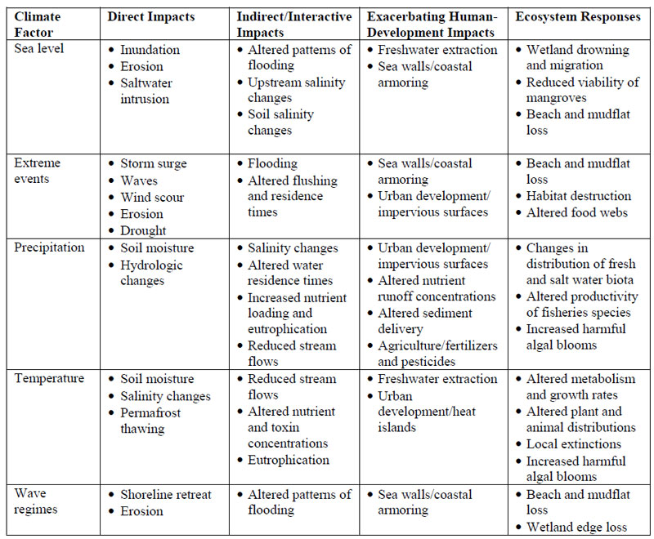
The climatic factors include rainfall and water, light, temperature, relative humidity, air, and wind. They are a biotic components, including topography and soil, of the environmental factors that influence plant growth and development.
Human activities in most parts of the world are transforming the global environment. Among the numerous factors that contribute to global environmental change, mention can be made of land-use change, desertification and deforestation, loss of biodiversity, air pollution, ozone depletion, and climate change. Changes in average and extreme patterns of weather and climate are capable of putting vital resources under pressure. Ecosystems become more susceptible to the emergence, invasion, and spread of opportunistic species. Many of these environmental pressures act in a synergistic manner, thereby compounding the stress situation and the adverse effects that a degraded environment may have on human activities and the carrying capacity of a particular region. Humans are not only the receptors of environmental change but are also in numerous instances the drivers of change. Over-exploitation of resources in the industrialized world and unsustainable economic policies have given rise to many of the factors generating global change. In less developed countries, high population growth is linked to environmental degradation because local inhabitants attempt to maintain or improve their resource base and economic level through the over-exploitation of their environment. This takes place in general without any long-term environmental management strategy; resources can thus become rapidly depleted or ineffective.
One of the more visible and global consequences of climate change is sea-level rise,
which is the result of the combined effects of thermal expansion of water and the
additional influx of fresh water to the oceans from melting mountain glaciers and
ice sheets.
The impacts of climate change on human health, is complex because populations have different vulnerabilities to change and susceptibility to disease. These depend on the general levels of hygiene practices, clothing, housing, and medical and agricultural traditions. Adaptation to the spread of disease is determined by the economic level of a given population, the quality and coverage of medical services, and the integrity of the environments. Thus human biological and psychological factors are primary determinants, but ecological and global systems are also involved, as are economics and access to health care, which shape the vulnerability of societies to disease. Shifts in environmental conditions, interacting with the biology of disease agents, can exert profound effects. Changes in how land is used affect the distribution of disease carriers, such as rodents or insects, while climate influences their range and affects the timing and intensity of outbreaks. Changing social conditions, such as the growth of multimillion-inhabitant cities in the developing world and widespread ecological change, are today contributing to the spread of infectious diseases.
In rural Africa and the Middle East, when droughts dry up the regular water supply, rural and impoverished families are forced to resort to drinking the dirty, sediment-and-parasite-laden water that sits in puddles and small pools on the surface of the earth. Many are aware of the presence of contamination, but will drink from these sources nonetheless in order to avoid dying of dehydration. It has been estimated that up to 80% of human illness in the world can be attributed to contaminated water.
Rates of suicide in Australian farmers are higher than the national average, but during times of drought these rates increase. Research has shown that extreme weather events lead to a variety of mental health disorders from the impacts of loss, social disruption, and displacement. Some examples of common mental health conditions associated with such events include: acute traumatic stress, post-traumatic stress disorder, depression, complicated grief, anxiety disorders, sleep difficulties, sexual dysfunction, and drug or alcohol abuse.
Climate change may dramatically impact habitat loss, for example, arid conditions may cause the collapse of rainforests, as has occurred in the past.
The consequences of climate change and poverty are not distributed uniformly within communities. Individual and social factors such as gender, age, education, ethnicity, geography and language lead to differential vulnerability and capacity to adapt to the effects of climate change. Climate change effects such as hunger, poverty and diseases like diarrhea and malaria, disproportionately impact children, i.e. about 90 percent of malaria and diarrhea deaths are among young children.
Reference:
http://www.wwfblogs.org/climate/sites/default/files/coastal-impacts-nat-res-800px.jpg

