|  |
| --- |
|  |

Stresses occur in any material that is subject to a load or any applied force. There are many types of stresses, but they can all be generally classified in one of six categories: residual stresses, structural stresses, pressure stresses, flow stresses, thermal stresses, and fatigue stresses.

Residual Stresses

*Residual stresses* are due to the manufacturing processes that leave stresses in a material. Welding leaves residual stresses in the metals welded. Stresses associated with welding are further discussed later in this module.

Structural Stresses

*Structural stresses* are stresses produced in structural members because of the weights they support. The weights provide the loadings. These stresses are found in building foundations and frameworks, as well as in machinery parts.

Pressure Stresses

*Pressure stresses* are stresses induced in vessels containing pressurized materials. The loading is provided by the same force producing the pressure. In a reactor facility, the reactor vessel is a prime example of a pressure vessel.

Flow Stresses

*Flow stresses* occur when a mass of flowing fluid induces a dynamic pressure on a conduit wall. The force of the fluid striking the wall acts as the load. This type of stress may be applied in an unsteady fashion when flow rates fluctuate. Water hammer is an example of a transient flow stress.

Thermal Stresses

*Thermal stresses* exist whenever temperature gradients are present in a material. Different temperatures produce different expansions and subject materials to internal stress. This type of stress is particularly noticeable in mechanisms operating at high temperatures that are cooled by a cold fluid. Thermal stress is further discussed in Module 3.

Fatigue Stresses

*Fatigue stresses* are due to cyclic application of a stress. The stresses could be due to vibration or thermal cycling. Fatigue stresses are further discussed in Module 4.

The importance of all stresses is increased when the materials supporting them are flawed. Flaws tend to add additional stress to a material. Also, when loadings are cyclic or unsteady, stresses can effect a material more severely. The additional stresses associated with flaws and cyclic loading may exceed the stress necessary for a material to fail.

Types of Applied Stress

Stress intensity within the body of a component is expressed as one of three basic types of internal load. They are known as tensile, compressive, and shear. Figure 1 illustrates the different types of stress. Mathematically, there are only two types of internal load because tensile and compressive stress may be regarded as the positive and negative versions of the same type of normal loading.

However, in mechanical design, the response of components to the two conditions can be so different that it is better, and safer, to regard them as separate types.

As illustrated in Figure 1, the plane of a tensile or compressive stress lies perpendicular to the axis of operation of the force from which it originates. The plane of a shear stress lies in the plane of the force system from which it originates. It is essential to keep these differences quite clear both in mind and mode of expression.

FORCE        FORCE

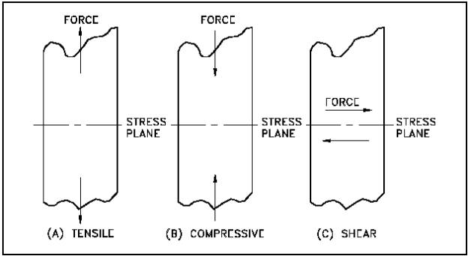

Figure 1 Types of Applied Stress

Tensile Stress

*Tensile stress* is that type of stress in which the two sections of material on either side of a stress plane tend to pull apart or elongate as illustrated in Figure 1(a).