Noise
Sound that is loud, unpleasant, unexpected, or undesired.
Sound and Noise
Sound is a form of energy that is transmitted by pressure variations which the human ear can detect.
Noise is unwanted sound. Depending on other factors, the sound may be perceived as noise.
In hearing, we also tend to organize sounds into auditory objects or streams and use the principles of grouping to help us to segregate those components we are interested in from others. We are thus able to focus our listening attention to a particular noise source and distinguish an auditory object from the background noise.
The human ears can detect not only changes in the overall sound pressure level but are so sophisticated that they can detect sound, the sound pressure level of which is well below the background noise level.
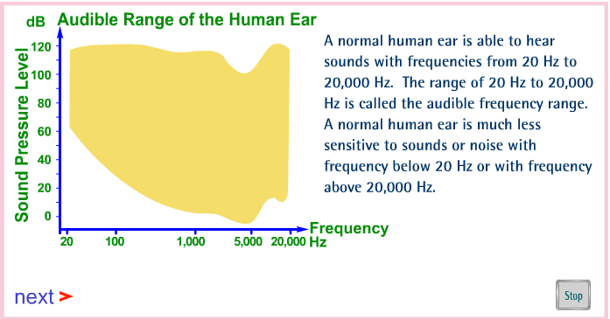
Noise Criteria
While there are variations in individual perception of the strength of a sound, studies have shown that to a good approximation, the sound is perceived twice as loud if the sound level increases by 10 dB. Similarly, a 20 dB increase in the sound level is perceived as four times as loud by the normal human ear.

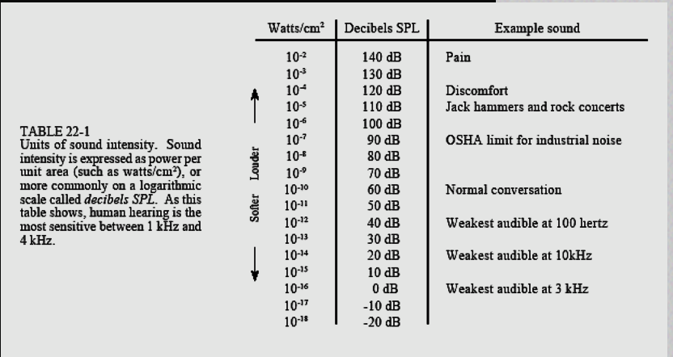

Occupational Exposure Levels reported and recommended by I-INCE(International Institute of Noise Control Engineering )
There is general agreement that progression in hearing loss at
frequencies of 500, 1000, 2000, and 3000 Hz eventually will result in impaired hearing, i.e.,
inability to hear and understand speech..
1. Limit of 85 dB(A) for 8 hour work shift for jurisdiction desirable as soon as possible.
2. Maximum sound pressure level as limit of 140 dB for C-weighted peak.
3. Exchange rate of 3 dB per doubling or halving of exposure time.
4. Efforts to reduce levels to the lowest economically and technologically reasonable values.
5. In the design stage consideration to sound and vibration isolation between noisier and quieter areas, significant amount of acoustical absorption in rooms occupied by people.
6. Purchase specifications for machinery should contain clauses specifying the maximum emission values.
7. A long-term noise control program at each workplace where daily exposure exceeds 85 dB(A).
8. Use of personal hearing protection should be encouraged when engineering noise control
measures are insufficient to reduce daily exposure to 85 dB(A), should be mandatory when
exposure level is over 90 dB(A).
9. Employers should conduct audiometric testing of workers exposed to more than 85 dB(A) at least every three years, test results should be preserved in the employee‘s file.

Effects of Noise
Temporary noise exposure produces readily reversible physiologic changes. However, noise exposure of sufficient intensity, duration, and unpredictability provokes changes that may not be so readily reversible.
Noise pollution is not believed to be a cause of mental illness, but it is assumed to accelerate and intensify the development of latent mental disorders.
Noise pollution may cause or contribute to the following adverse effects: anxiety, stress, nervousness, nausea, headache, emotional instability, argumentativeness, sexual impotence, changes in mood, increase in social conflicts, neurosis, hysteria, and psychosis.
Noise levels above 80 dB are associated with both an increase in aggressive behavior and a decrease in behavior helpful to others.
Cognitive and language development and reading achievement are diminished in noisy homes,

Effects of Noise Health effects of noise by WHO
Noise causes a wide range of health effects, including:

Sleep disturbance
To some degree, the immediate effects of sleep disturbance in adults are quantified through:
- the number and duration of nocturnal awakenings;
- the number of changes in sleep stage;
- the number of electroencephalographic arousals;
- global changes in total amount of sleep stages or in their time organization (sleep architecture).
Exposure–response curves exist for awakenings, based on laboratory results and self-assessment questionnaires. Nevertheless, many questions remain on how poor sleep relates to or induces poor health.

Cardiovascular effects
Among other non-auditory health endpoints, short-term changes in circulation including blood pressure, heart rate, cardiac output and vasoconstriction, as well as stress hormones have been studied in experimental settings for many years. Classical biological risk factors have been shown to be elevated in subjects that were exposed to high levels of noise. In the past several years, epidemiological evidence was accumulated supporting the hypothesis that persistent noise stress increases the risk of cardiovascular disorders including hypertension and ischaemic heart disease.

Loss of productivity in adults
Noise has negative impacts on cognitive performance. For recall and reading, a reduction of the day and night noise level by 5 dB(A) within the range of 65–80 dB(A) was shown to improve performance by almost 10%. For attention and memory, a 5 dB(A) reduction in average noise level results in approximately 2–3% improvement of performance. These adverse impacts of noise on cognitive performance can lead to a reduction in the productivity at work and the learning performance at school.

Learning impairment in children
Children chronically exposed to loud noise show impairments in attention, memory, problem-solving ability and learning to read.

Hearing impairment
Studies and data are not sufficient to derive relationships between community or social specific noise exposure and hearing impairment in adults and children. Nevertheless, assuming that social noise is not significantly different from occupational noise and that the equal energy principle is applicable, exposure–response curves can be established on the basis of International Organization for Standardization (ISO) standard 1999 (on determination of occupational noise exposure and estimation of noise-induced hearing impairment), which uses an audiometric threshold shift at 4 kHz.

