Practical No. 10

Objective:
Demonstrate the characteristics & usage of Coordinate Measuring Machine.

Tools & Equipment:
Study material
computer with office installed

Theory:
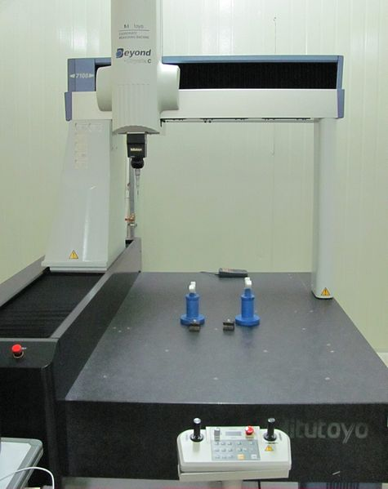
A coordinate measuring machine is a device for measuring the physical geometrical characteristics of an object. This machine may be manually controlled by an operator or it may be computer controlled. Measurements are defined by a probe attached to the third moving axis of this machine. Probes may be mechanical, optical, laser, or white light, amongst others. A machine which takes readings in six degrees of freedom and displays these readings in mathematical form is known as a CMM.

Technical Structure
The typical 3 "bridge" CMM is composed of three axes, an X, Y and Z. These axes are orthogonal to each other in a typical three dimensional coordinate system. Each axis has a scale system that indicates the location of that axis. The machine will read the input from the touch probe, as directed by the operator or programmer. The machine then uses the X,Y,Z coordinates of each of these points to determine size and position with micrometer precision typically.
A coordinate measuring machine (CMM) is also a device used in manufacturing and assembly processes to test a part or assembly against the design intent. By precisely recording the X, Y, and Z coordinates of the target, points are generated which can then be analyzed via regression algorithms for the construction of features. These points are collected by using a probe that is positioned manually by an operator or automatically via Direct Computer Control (DCC). DCC CMMs can be programmed to repeatedly measure identical parts, thus a CMM is a specialized form of industrial robot.
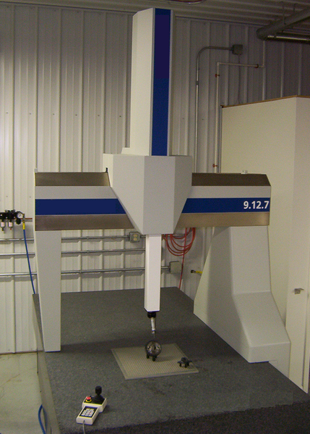

Mechanical probe
In the early days of coordinate measurement mechanical probes were fitted into a special holder on the end of the quill. A very common probe was made by soldering a hard ball to the end of a shaft. This was ideal for measuring a whole range of flat, cylindrical or spherical surfaces. Other probes were ground to specific shapes, for example a quadrant, to enable measurement of special features. These probes were physically held against the workpiece with the position in space being read from a 3-Axis digital readout (DRO) or, in more advanced systems, being logged into a computer by means of a footswitch or similar device. Measurements taken by this contact method were often unreliable as machines were moved by hand and each machine operator applied different amounts of pressure on the probe or adopted differing techniques for the measurement.
A further development was the addition of motors for driving each axis. Operators no longer had to physically touch the machine but could drive each axis using a handbox with joysticks in much the same way as with modern remote controlled cars. Measurement accuracy and precision improved dramatically with the invention of the electronic touch trigger probe. The pioneer of this new probe device was David McMurtry who subsequently formed what is now Renishaw plc.^{[2]} Although still a contact device, the probe had a spring-loaded steel ball (later ruby ball) stylus. As the probe touched the surface of the component the stylus deflected and simultaneously sent the X.Y,Z coordinate information to the computer. Measurement errors caused by individual operators became fewer and the stage was set for the introduction of CNC operations and the coming of age of CMMs.
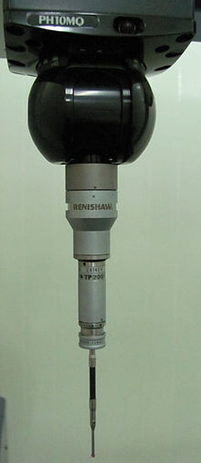
Motorized automated probe head with electronic touch trigger probe
Optical probes are lens-CCD-systems, which are moved like the mechanical ones, and are aimed at the point of interest, instead of touching the material. The captured image of the surface will be enclosed in the borders of a measuring window, until the residue is adequate to contrast between black and white zones. The dividing curve can be calculated to a point, which is the wanted measuring point in space. The horizontal information on the CCD is 2D (XY) and the vertical position is the position of the complete probing system on the stand Z-drive (or other device component). This allows entire 3D-probing.

New Probing Systems
There are newer models that have probes that drag along the surface of the part taking points at specified intervals, known as scanning probes. This method of CMM inspection is often more accurate than the conventional touch-probe method and most times faster as well.
The next generation of scanning, known as non-contact scanning includes high speed laser single point triangulation,^{[3]} laser line scanning,^{[4]} and white light scanning,^{[5]} is advancing very quickly. This method uses either laser beams or white light that are projected against the surface of the part. Many thousands of points can then be taken and used to not only check size and position, but to create a 3D image of the part as well. This "point-cloud data" can then be transferred to CAD software to create a working 3D model of the part. These optical scanners often used on soft or delicate parts or to facilitate reverse engineering.
Micro metrology Probes:
Probing systems for micro scale metrology applications are another emerging area.^{[6][7]} There are several commercially available coordinate measuring machines (CMM) that have a microprobe integrated into the system, several specialty systems at government laboratories, and any number of university built metrology platforms for micro scale metrology. Although these machines are good and in many cases excellent metrology platforms with nonmetric scales their primary limitation is a reliable, robust, capable micro/nano probe.^{[citation needed]} Challenges for micro scale probing technologies include the need for a high aspect ratio probe giving the ability to access deep, narrow features with low contact forces so as to not damage the surface and high precision (nanometer level).^{[citation needed]} Additionally microscale probes are susceptible to environmental conditions such as humidity and surface interactions such as stiction (caused by adhesion, meniscus, and/or Van der Waals forces among others).^{[citation needed]}
Technologies to achieve micro scale probing include scaled down version of classical CMM probes, optical probes, and a standing wave probe ^{[8]} among others. However, current optical technologies cannot be scaled small enough to measure deep, narrow feature, and optical resolution is limited by the wavelength of light. X-ray imaging provides a picture of the feature but no traceable metrology information.
Physical Principles:
Optical probes and/or laser probes can be used (if possible in combination), which change CMMs to measuring microscopes or multi-sensor measuring machines. Fringe projection systems, theodolite triangulation systems or laser distant and triangulation systems are not called measuring machines, but the measuring result is the same: a space point. Laser probes are used to detect the distance between the surface and the reference point on the end of the kinematic chain (i.e.: end of the Z-drive component). This can use an interferometrical function, focus variation, light deflection or a half beam shadowing principle.

Portable Coordinate Measuring Machines
Portable CMMs are different from "traditional CMMs" in that they most commonly take the form of an articulated arm. These arms have six or seven rotary axes with rotary encoders, instead of linear axes. Portable arms are lightweight (typically less than 20 pounds) and can be carried and used nearly anywhere. The inherent trade-offs of a portable CMM are manual operation (always requires a human to use it), and overall accuracy is somewhat to much less accurate than a bridge type CMM. Certain non-repetitive applications such as reverse engineering, rapid prototyping, and large-scale inspection.

Conclusion:
The coordinate measuring machine was demonstrated in CIM Lab.

