Principles of Seating Design:
Height of the chair and work bench should be arranged in a way that permits
comfortable work posture. To ensure this
• Height of the chair should be such that top of the work table is about 50 mm below
the elbow level of the operator.
• Height of the table should be such that worker can work in both standing and
sitting positions.
• Flat foot rests should be provided for sitting workers.
• Figure 1.12 shows the situation with respect to bench heights and seat heights.
• The height and back of the chair should be adjustable.
• Display panel should be at right angles to the line or sight of the operator.
(f) An instrument with a pointer should be employed for check readings where as for
quantitative readings, digital type of instrument should be preferred.
(g) Hand tools should be possible to be picked up with least disturbance or rhythm and
symmetry .
(h) Foot pedals should be used, wherever possible, for clamping declamping and for
disposal of finished work.
(i) Handles, levers and foot pedals should be possible to be operated without changing
body position.
(j) Work place must be properly illuminated and should be free from glare to avoid eye
strain.
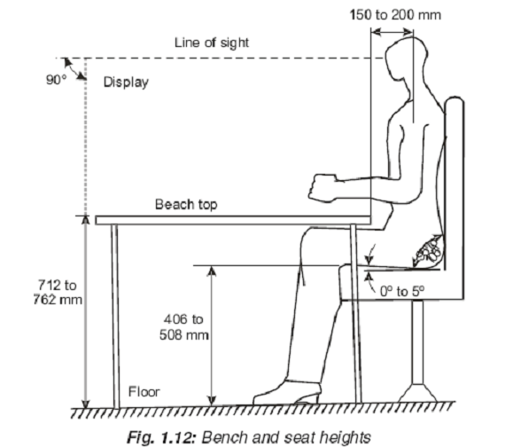
(k) Locaition of seat should be should be free from the presence of disagreeable elements like heat,
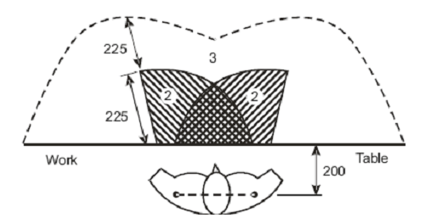
smoke,
dust, noise, excess humidity, vibrations etc.
The seating design must follow some
- Design for extremes of individuals (or the population):
a. Maximum: automobile interiors, escape hatches, doorway
b. Minimum: applied force, reach distances
c. Most designs cover 5th through 95th percentile
- Design with an adjustable range:
a. Design should "fit" 5th through 95th percentile of relevant population
b. Involves a trade-off with cost/complexity
- Design for the average - vs. design for the extreme
(seat height, counter tops, letter height) Applied Anthropometric and Workplace
- Variability of population :
Anthropomorphic measurements are a function of age, gender, nationality, user type and several
other factors that must be taken under consideration.

