Work Place arrangement & Work Place Design Considerations
Work Place Environment.
(Also mention the light and sound limits in the environment from the illumination & noise topic)
(a) The environment aspect includes considerations regarding light, climatic conditions
(i.e., temperature, humidity and fresh air circulation), noise, bad odour, smokes, fumes, etc., which
affect the health and efficiency of a worker.
(b) Day light should be reinforced with artificial lights, depending upon the nature of work.
(c) The environment should be well-ventilated and comfortable.
(d) Dust and fume collectors should preferably be attached with the equipments giving rise
to them.
(e) Glares and reflections coming from glazed and polished surfaces should be avoided.
(f) For better perception, different parts or sub-systems of equipment should be coloured
suitably. Colours also add to the sense of pleasure.
(g) Excessive contrast, owing of colour or badly located windows, etc., should be eluded.
(h) Noise, no doubt distracts the attention (thoughts, mind) but if it is slow and continuous,
workers become habituated to it. When the noise is high pitched, intermittent or sudden, it
is more dangerous and needs to be dampened by isolating the place of noise and through
the use of sound absorbing materials.
2. Work place layout Design considerations
(a) Materials and tools should be available at their predetermined places and close to the worker.
(b) Tools and materials should preferably be located in the order in which they will be used.
(c) The supply of materials or parts, if similar work is to be done by each hand, should be
duplicated. That is materials or parts to be assembled by right hand should be kept on right
hand side and those to be assembled by the left hand should be kept on left hand side.
(d) Gravity should be employed, wherever possible, to make raw materials reach the operator and to deliver material at its destination (e.g., dropping material through a chute).
(e) Height of the chair and work bench should be arranged in a way that permits
comfortable work posture. To ensure this
• Height of the chair should be such that top of the work table is about 50 mm below
the elbow level of the operator.
• Height of the table should be such that worker can work in both standing and sitting positions.
• Flat foot rests should be provided for sitting workers.
• Figure 1.12 shows the situation with respect to bench heights and seat heights.
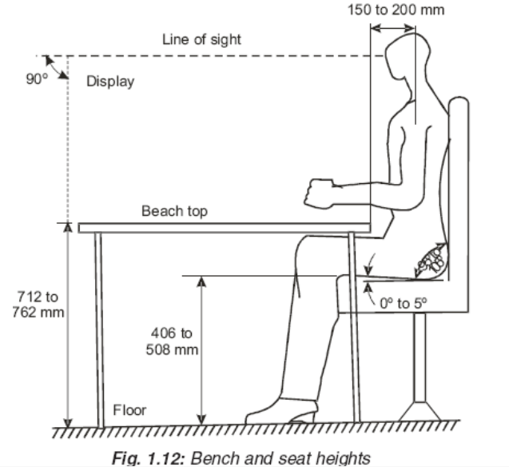
• The height and back of the chair should be adjustable.
• Display panel should be at right angles to the line or sight of the operator.
(f) An instrument with a pointer should be employed for check readings where as for
quantitative readings, digital type of instrument should be preferred
(g) Hand tools should be possible to be picked up with least disturbance or rhythm and
symmetry of movements.
(h) Foot pedals should be used, wherever possible, for clamping declamping and for disposal of finished work.
(i) Handles, levers and foot pedals should be possible to be operated without changing body position.
(j) Work place must be properly illuminated and should be free from glare to avoid eye strain.
(k) Work place should be free from the presence of disagreeable elements like heat, smoke, dust, noise, excess humidity, vibrations etc.
Suggested work place layout
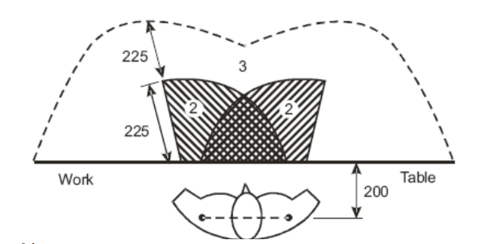
Figure 1.13 shows a work place layout with different areas and typical dimensions. It shows the left hand covering the maximum working area and the right hand covering the normal working area.
Normal working area
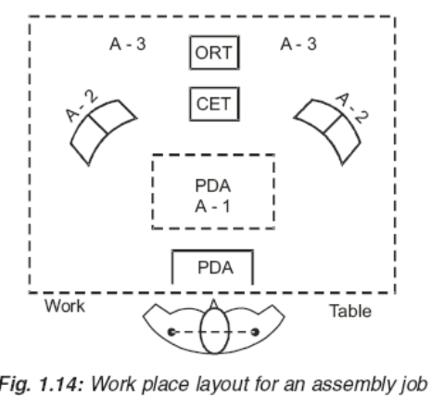
It is within the easy reach of the operator.
Maximum working area
It is accessible with full arm stretch. Figure 1.14 shows work place layout for assembling
small component parts. A-1 is the actual working area and the place of assembly (POA) where
four component parts P-1, P-2, P-3, and P-4 are assembled together. Bins containing P-1, P-2, P-3, and P-4 and commonly employed tools (CET) (like screw driver, plier, etc.) lie in the normal working area A-2.
ORT
Occasionally required Tools (ORT) (hammers etc.) lie in the maximum working area A-3. After
the assembly has been made at POA, it is dropped into the cut portion in the work table – PDA
(Place for dropping assemblies) from where the assembly is delivered at its destination with the
help of a conveyer. This work place arrangement satisfies most of the principles of motion economy.

